LAB 14
Set Operators

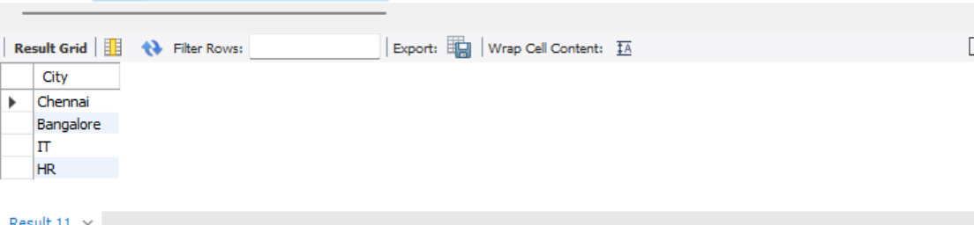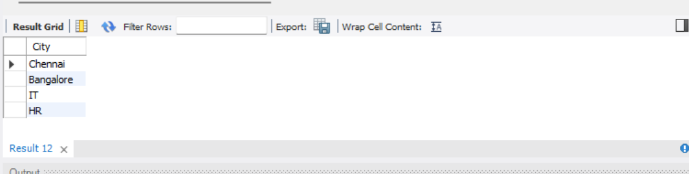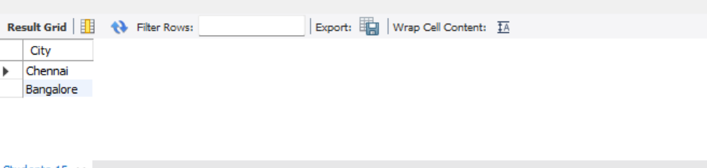

1. UNION: Combines city names and department names, removing duplicate values.
2. UNION ALL: Combines city names and department names, including duplicate values.
3. INTERSECT: Displays only the values common to both City and DeptName. In MySQL, use an INNER JOIN alternative if INTERSECT is unsupported.
4. MINUS / EXCEPT: Displays city names from Students that do not exist in Department. MySQL uses a NOT EXISTS alternative because MINUS is not supported.

